|  |
| --- |
| HCCOMP2, HCCOMPE2, BSHC2, BSHCE2, BSHTM2 |
| Requirements Specification (RS) |
| [Type the document subtitle] |

|  |
| --- |
| Jane Keyes, Tadhg Savage, Karl Miller, Aisha Ntuli  2/1/2023 |

**Table of Contents**

1 Introduction 4

1.1 Purpose 4

1.2 Project Scope 4

1.3 Definitions, Acronyms, and Abbreviations 4

2 User Requirements Definition 4

3 Requirements Specification 4

3.1 Functional requirements 4

3.1.1 Use Case Diagram 5

3.1.2 Requirement 1 <name of requirement in a few words> 5

3.1.3 Requirement 2 <name of requirement in a few words> 6

3.2 Non-Functional Requirements 7

3.2.1 Performance/Response time requirement 8

3.2.2 Availability requirement 8

3.2.3 Recover requirement 8

3.2.4 Robustness requirement 8

3.2.5 Security requirement 8

3.2.6 Reliability requirement 8

3.2.7 Maintainability requirement 8

3.2.8 Portability requirement 8

3.2.9 Extendibility requirement 8

3.2.10 Reusability requirement 8

3.2.11 Resource utilization requirement 8

4 GUI 8

5 System Architecture 8

6 System evolution 8

# Introduction

## Purpose

The purpose of this document is to set out the requirements for the development of our Virtual Reality (VR) game called “Cooktastrophe”. This game is a simulator for running a restaurant. The user will be allowed to prepare and cook food, serve customers, make money, use money to upgrade various aspects and appliances of the restaurant. The user will be based within the restaurants kitchen where they will have to deal with multitasking. The games difficulty increases as the user progresses through it.

The target demographic for this came is from ages 13 and up. The game is light-hearted and accessible making it suitable for younger teens to grasp while being challenging enough for users of all ages. “Cooktastrophe” will be for all the family to enjoy with its bright colours, Voxel graphic’s, non-offensive music, and entertaining but challenging gameplay.

## Project Scope

The Scope of the project is to develop a VR game.

Group two of the team project module were involved in communications with one another to meet the following requirements.

The system shall have art and graphics developed using Blockbench and will be made using Unity.

Th goals which we are envisioning for this project include modifying Unity’s VR system to suit our game e.g., holding and picking up things. Our deliverables for this project include an initial project proposal, a requirements specification, a mid-point presentation ending with a final software presentation, Report, Application and evidence of communication.

Our tasks include creating the game’s graphics, creating the lore and “world” of “Cooktastrophe” which includes a point system comprised of health bars, money etc. The costs of this endeavour are rather minimal considering that the software we are using on which to make these graphics and the game itself are actually free I would say the only cost we have encountered so far which was also rather optional was downloading the game that our game was loosely inspired by called “Plate Up” to experience the feel and atmosphere of the game and it was under 10 euro. All other costs mostly came down to time costs.

## Definitions, Acronyms, and Abbreviations

**3D** **Three-Dimensional** - This Relates to or denotes a film or video game that creates an impression of depth and solidity, typically by means of stereoscopic techniques.

**Stereoscopic** This relates to or denotes a process by which two photographs of the same object taken at slightly different angles are viewed together, creating an impression of depth and solidity.

**VR**  **Virtual Reality** – This is a computer-generated simulation of a 3D image or environment that can be interacted with in a seemingly real or physical way by a person using special electronic equipment, such as a helmet with a screen inside or gloves with fitted sensors.

**XR** **Mixed Reality** – This is a medium of immersive, computer-generated enviroments in which elements of a physical and virtual environment are combined.

**Voxel** This is a computer-based modelling or graphic simulation. Each of an array of elements of volume that constitute a notional 3D space, especially each of an array of discrete elements into which a representation of a 3D object is divided.

……..

# User Requirements Definition

The user requirements are defined by the set of objects and requirements for the system from the customer’s perspective. In this case the client wants:

* A Virtual Reality game that can be interacted with via VR technology (headsets etc.).
* To be able to communicate with customers in the game.
* To be able to cut and prepare foods and dishes.
* To serve prepared food to customers.
* To take payment from the customer to create an income.
* To view their health status using a star rating.
* To upgrade restaurant appliances using generated income.
* To be able to pause and resume gameplay at their command.
* To be able to turn sounds effects on and off.
* To be able to turn music on and off.
* To end games at their command
* To progress to new levels in the game.
* To begin a new game at their command.

# Requirements Specification

“Cooktastrophe” will begin gameplay with the option of watching an interactive tutorial. This tutorial will breakdown multiple aspects of the game, describing to the user what certain objects are and how to use them. This tutorial should last between 5-10 minutes, after which the user should be able to play the games beginner levels with ease. The difficulty of the game will increase as users progress through it, meaning the more advanced the player, the more advanced the level will be.

## Functional requirements

1. The system must display an initial start-up menu when the game is started up
2. The game must only run on a compatible VR device.
3. The system must begin tutorial round if player chooses tutorial option.
4. The system must begin new game in player chooses new game option.
5. The system must allow the user to take orders from customer.
6. The system must allow the player to prepare the correct food for the customer.
7. The system must display the customers satisfaction to the player.
8. The system must allow the user freedom within the restraints of the restaurant.
9. The system must allow the player to clear dirty tables.
10. The system must reward the player with money if tables are cleared.
11. The system must allow the player to upgrade appliances within the restaurant and kitchen.
12. The system must allow the user to progress to the level when one is completed.

### Use Case Diagram

**Main flow**

1. The system identifies the first customer has walked into the restaurant.
2. The <Actor> will then greet the customer and take their order.
3. The system then responds by allowing the user to take note of the customer’s order.
4. The <Actor> will then use this gathered information to prepare, make and serve the dish of the customer’s request.
5. The system acting as the restaurants customer then takes the food eats it, pays, leaves dirty dishes, and then leaves the restaurant. The system then enters a wait state for the user to come clear the table of its dirty dishes to allow another restaurant goer to sit there.

**Alternate flow**

1. A1 : <Alternate flow first customer >
2. The system identifies the first customer has walked into the restaurant.
3. The <Actor> might not greet the customer which would leave the game in a wait state, as the customer waits to be greeted for their order to be taken. If the user takes too long to greet the customer their patience meter will gradually start to decrease. The longer they are kept waiting the more impatient they will grow and the faster their patience will start to dwindle. If a customer gets so impatient that they leave this will result in a direct strike on the user’s health and the star rating of the restaurant.
4. The system then responds by going back to its original state and queueing a new customer to enter the restaurant.
5. The use case continues at position 7 of the main flow.

**Exceptional flow**

1. E1 : <Exceptional flow first customer >
2. The system identifies the first customer has walked into the restaurant.
3. The <Actor>is unable to respond to this customer due to an unconnected headset and for the game to be played the headset must be connected which needs the user to restart the game with a connected headset.
4. The use case continues at position 7 of the main flow

**Termination**

After dealing with the previous customer the system will then present the next customer.

**Post condition**

The system goes into a wait state to begin the process of attending to a customer again.

### Requirement 2 : User begins game play with either tutorial mode or begins the game straight away.

1. Description & Priority

Some of the main requirements would be good overall performance of the game. The memory saving abilities along with helping to minimize motion sickness due to it being a VR game. Another would be lag prevention.

Requirement 1: User begins the game either choosing tutorial mode or beginning the game straight away.

1. Use Case

**Scope**

The scope of this use case is to describe the overall atmosphere and flow of the game.

**Description**

This use case describes the atmosphere and flow of the game.

**Flow Description**

**Precondition**

The system is in initialisation mode the user then presses play to begin the game.

**Activation**

This use case starts when an <Actor>which in this case is the user begins the game by pressing play from here

**Main flow**

1. The system identifies that the player has begun the game.
2. The <Actor> presses play to begin the game
3. The system responds with asking them if they would like to begin with tutorial mode or play the game with no tutorial.
4. The <Actor> from here would choose if they would like to play tutorial mode or if they would like to just begin the game.
5. The system if they choose tutorial mode then begins the interactive tutorial in which the system teaches the user how to play the game through interactivity.
6. After the tutorial is finished the system positions them at the start of the game.

**Alternate flow**

1. A1 : <Alternate Version 1 >
2. The system prompts the user to choose between the tutorial mode of the game or to begin the game right away.
3. The <Actor> chooses to begin the game with no interactive tutorial.
4. The use case continues at position 6 of the main flow with the system positioning the user at the beginning of the game.

**Exceptional flow**

1. E1 : <Exceptional Flow 1>
2. The system is stuck without a headset and needs to be restarted in order for the game to take place
3. The <Actor> would then restart the game with a connected headset and begin the game.
4. The use case continues at position 6 of the main flow.

**Termination**

The system presents the next task which would be a customer.

**Post condition**

The system goes into a wait state

1. Requirement 2 <name of requirement in a few words>
   1. Description & Priority

Requirement 2: User is faced with their first customer.

This is of importance to the game because how customers are treated within the game is integral to the overall success of the restaurant

1. Use Case

**Scope**

The scope of this use case is to familarise the user with how the game works and how they must treat customers in order to have a successful restaurant experience.

**Description**

This use case describes the relationship of the user with the customers.

**Flow Description**

**Precondition**

The system is in initialisation mode the user begins gameplay through either a tutorial run or beginning the game directly once the game has begun either post tutorial or without a tutorial the user is then presented with their first official customer which they must tend to.

**Activation**

This use case starts when an <Actor> is presented with their first official customer for them to serve minus the help of a tutorial.

**Main flow**

1. The system identifies the first customer has walked into the store.
2. The <Actor> will then greet the customer and take their order.
3. The system then responds by allowing the user to take note of the customer’s order.
4. The <Actor> will then use this gathered information

The system goes into a wait state

**List further functional requirements here, using the same structure as for Requirements 1 & 2. Most systems would have at least five main requirements.**

## Non-Functional Requirements

### Performance/Response time requirement

The game should run on compatible VR devices without the interference of bugs or load time. Access to the internet should not interfere with the performance/response time of the game.

### Availability requirement

The game should be readily available to players with a working/compatible VR device.

### Recover requirement

### Security requirement

Users should not be required to input any personal information that may be compromised by malicious hackers.

### Reliability requirement

The game should be able to run at any given time to a player that has the game downloaded and has the compatible VR device.

### Maintainability requirement

**The system should be capable of being maintained cost effectively over its lifespan. Aspects such as debugging, upgrading, expanding, and improving the game should all be considered when maintaining the games integrity and enjoyability.**

### Portability requirement

The game should be able to run on any compatible device with downloaded software. The game should be able to run anywhere, at any time. There should be no constraints on when or where the game can be played.

### Extendibility requirement

The possibility for further game updates and expansions should be made available to the user. The user should be able to choose whether to update the game or not.

### Reusability requirement

The game should run without having to redownload the software every time the user wants to play it. Once the player has the game downloaded, they should be able to access it at all times.

# GUI

WIP Logo

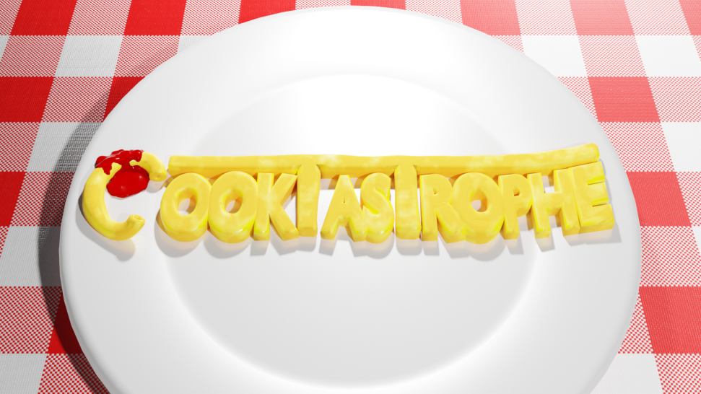

VR Games have minimal User Interface elements aside from the world around them, so most UI will come in the form of small popups that show the progression of a process, or the patience of a customer:

# System Architecture

Provide a high-level architecture diagram to illustrate how the different parts/technologies of your system work together

# System Evolution

This section describes how the system could evolve over time.